**Motion Equation Practice**

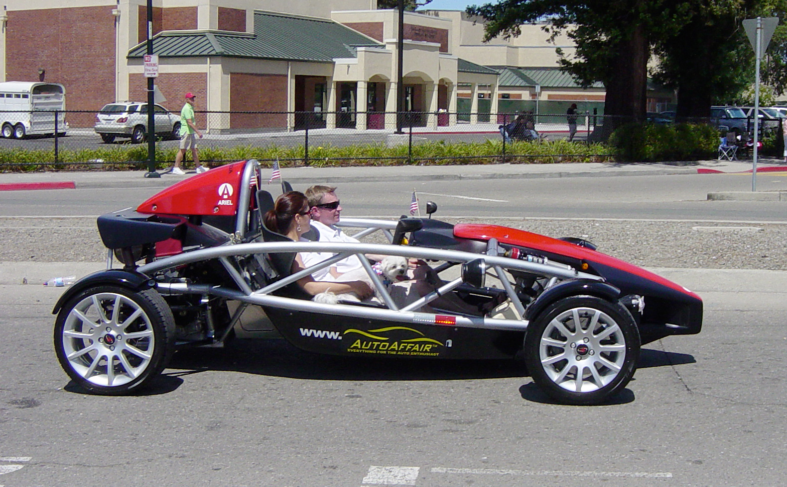

1) A race car slows from 36 m/s to 15 m/s over 3.0 s. What is the acceleration of this car’s brakes?

2) If a motorcycle accelerates from rest at 5.3 m/s2, how long will it take it to reach 28 m/s?

3) A go-kart traveling at 22 m/s speeds up to 44 m/s over an 11 s interval. How far does it go?

4) A rocket traveling at 88 m/s undergoes an acceleration of 4 m/s2 over 300 meters, what is its final velocity?

5) A car accelerates from 15 m/s to 25 m/s while it travels 125 m. How long does this motion take?

6) A driver brings a car traveling at 22 m/s to a full stop in 2 s.

a) What is the car’s acceleration?

b) How far does it travel before stopping?

7) An airplane starts from rest and accelerates at 3 m/s2 for 30 s before leaving the ground. What is its displacement during this time?

8) Starting from rest, a race car moves 110 m in 5.0 s. What is the car’s acceleration?

9) A biker passes a lamppost at the crest of a hill at 4.5 m/s. She accelerates down the hill at 4.0 m/s2 for 12 seconds. How far does she move down the hill?

10) An airplane accelerates from 21 m/s at a rate of 3 m/s2 over 535 m. What is its final velocity?